Online Numeracy and Maths Games

Websites
http://www.mathscore.com/
https://www.topmarks.co.uk/maths-games
https://www.oxfordowl.co.uk/for-home/maths
https://www.transum.org/
https://nrich.maths.org/9084
https://www.timestables.co.uk/
https://www.ictgames.com/
http://www.primaryhomeworkhelp.co.uk/
https://mathszone.co.uk/

Apps (free with no login required)
- Sumdog
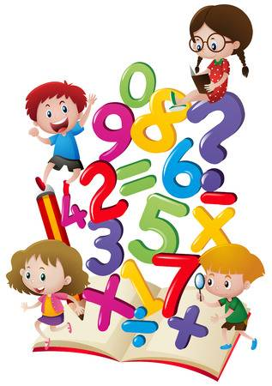
- 10 minutes a day times tables
- Maths champions lite for kids
- Times tables quiz
- Maths loop Lite
- Monster maths

