Online Literacy Games and Activities
Websites
https://www.doorwayonline.org.uk/literacy/

https://www.activityvillage.co.uk/

https://www.dltk-teach.com/

https://www.educationcity.com/ (individual logins have been sent home)

http://www.ictgames.co.uk/

https://www.topmarks.co.uk/
https://www.bbc.co.uk/bitesize/subjects/z8rdtfr

https://dogonalogbooks.com/printables/

https://www.linguascope.com/ (login: stmarksps password: stmarksrg)

https://www.oxfordowl.co.uk/for-home/

https://learnenglishkids.britishcouncil.org/

Apps for tablets/ipads
Sentence maker
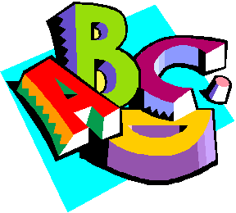
Make sentence
Easy spelling
Read&write
Abitalk phonics rhyming bee
Sight words
Rainbow sentences
Clicker sentences
Fun English

HWB websites:
https://www.jumpstartjonny.co.uk/home
https://www.gonoodle.com/
https://www.cosmickids.com/

