

Our

School Uniform

Standard

Dressing

the

St Mark’s Way

**Reducing the Cost of the School Day**

At St Mark’s we are committed to reducing the cost of the school day.

If you have any outgrown uniform that is still in very good condition please consider donating this to the school. Our Parent Council are supporting us to refresh and prepare items to be re-loved! We will then offer these items back to our school community.

Items that are left behind by children will initially be

displayed as lost property and if not claimed after a

period of time will be added to the collection.

We also have a great selection of jackets available which will be on display once we are able to host events again. In the meantime, please call the school office on 0141 634 4238 if you would like to take a look.

**Suppliers**

**All Ure Uniforms**

40 Hamilton Road, Rutherglen, G73 4DG

07857813333

**BE Schoolwear**

35 Argyle Street, Glasgow, G2 8AH

0141 221 4472

www.beuniforms.co.uk

**My Clothing at Tesco**

www.myclothing.com

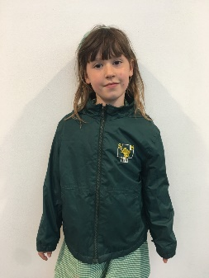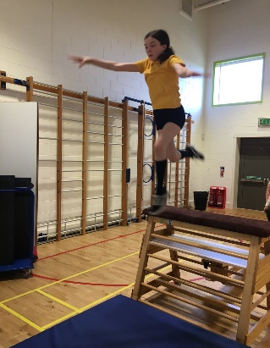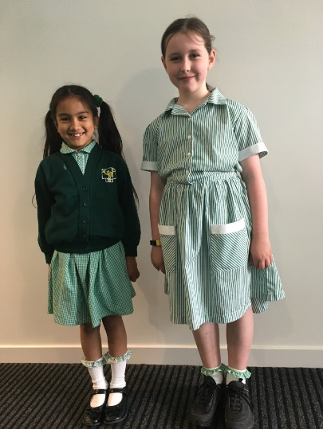

**Outdoor Jacket**

Children should come to school prepared for all weather! Any weatherproof jacket is acceptable.

**Boys**

Green blazer

School tie

White shirt

Grey trousers / shorts

Green jumper / sweatshirt

Black school shoes

**PE Kit**

Yellow polo shirt, green/black shorts to be kept in a small gym bag.

Indoor shoes must be worn every day!

We will let you know when these need replaced!

**Girls**

Green blazer

School tie

White shirt

Green skirt / pinafore (plain not tartan)

Green jumper/ cardigan/ sweatshirt

Black school shoes

Green Summer dress for warmer weather

3. Promotes the school’s identity in the community, with our

immediate neighbours and local business.

4. Assists staff in the task of supervising pupils and keeping

pupils safe on excursions.

**Wearing of**

**school uniform:**

1. Indicates a sense of pride in the school and helps pupils to form positive attitudes to the school and to their school work.

2. Protects children from the

harmful effects of social distinction and competitive dressing.