Physical Activity
PE with The Body Coach (Joe Wicks).
Joe Wicks has his own YouTube channel: The Body Coach TV.
He says he is planning to be the nations PE teacher every Monday to Friday at 9am while the schools are off. Make sure you have a watch, he is fantastic!

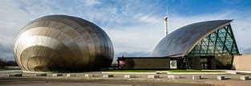 Glasgow Science Centre
From Thursday 19th March, the Glasgow Science Centre will be bringing a bit of science into your home every day at 10am to help keep everyone inspired in these challenging times.
Join them on their Facebook, Instagram or Twitter at 10am each day.
You can ask them questions and even let them know what you'd like to see! #GSCAtHome

Some other useful websites and apps

Linguascope website (type into Google)
Use this website to practise what you have learned in Spanish so far this year.
Username: stmarksps Password: stmarksrg
