PARISH OF ST. ANTHONY’S & ST. MARK’S
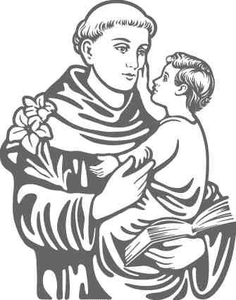
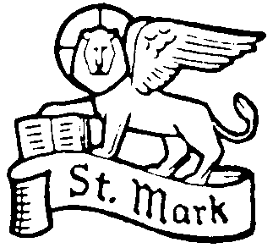
St. Mark’s St. Anthony’s
Fernhill Road, Mar Gardens,
Rutherglen, Springhall,
Glasgow G73 4DA Rutherglen G73 5JE
0141 634 3053

Charity No. SC011041

Parish Priest: Fr. Frank Dougan

2nd September 2020

Dear Parents and Carers,

Firstly, I hope you are all well and coping with difficult times for yourselves and your children.

As a parish, like everyone else, we missed the regular face-to-face meetings and Masses that we became so used to. We did develop our online contact through the website, Facebook, Twitter and our online Masses via YouTube. I will include the addresses for all these at the end of this letter.

Now that we have the children back at school, it is time to look forward to celebrating some of the things that had to be postponed earlier in the year. We also can look forward to the year ahead. After having spoken to our two headteachers, I can give you my proposals for one or two things.

First Reconciliation (Confession)
This was postponed at the last minute. That means that the boys and girls were well prepared, so we can go ahead quite soon with a little bit of revision. To make this simpler, we will not have a service with families etc. present. That would have meant waiting until 2021. Instead, I will go into the school on a weekday and celebrate it with the classes:
- In St Mark’s, it will be in October, with a date to be fixed;
- In St Anthony’s, the P3 and P4 will celebrate it together on a date/dates to be announced (possibly November)
It would be ideal to celebrate it as a community celebration as usual. However, we cannot tell what the restriction will be in the future, and it is important for the boys and girls to celebrate the Sacrament.

First Communion (P5)
I know that in some parishes, this will be celebrated over a number of dates in September / October. However, my preference is to wait until Spring next year (March or April). My thinking is this:
- The children have not been prepared for the Sacrament yet. This would take at least 6 weeks. This means we would have to set dates in October/November. You do not need me to tell you what the weather could be like;
- With present restrictions (no more than 50), we would either have celebrations with small groups of children and small groups of adults, or larger groups of children and no adults;
- We have a long tradition of making a fuss of the children all together. This is not essential, but I would like to try our best to maintain the traditional first communion day. While I cannot see into the future, we have a better chance of this happening in the Spring;
- Bishop Toal wrote to the priests of Motherwell Diocese advising us not to hurry into this. He also suggested the possibility that a number of celebrations over Autumn could lead to a number of parties across households as well. Unfortunately, not everyone is careful about following the rules, so this could lead to a spike caused by First Communion parties
There is no ideal answer to this, and I know that there is no solution that will please everyone. However, I believe that this will be the best compromise. I would wait until December before setting dates, as we might have a better sense of where things are going by that point.

First Communion (P4)
We can set dates as usual for May (these will be set in October and announced firstly at parish Masses). However, we must be aware that things could always change according to the situation with the pandemic at the time.

Confirmations (P6/P7)
We are awaiting information from the Diocese on this.

In Summary, I propose the following:

1. First Reconciliation
- In St Mark’s, it will be in October for P4; P3 to be announced;
- In St Anthony’s, the P3 and P4 will celebrate it together on a date/dates to be announced (possibly November).

2. First Communion
- P5 sometime in March/April next year. Dates to be announced in December;
- P4 in May next year. Dates to be announced in October.

3. Confirmation
- We will await guidance from the Diocese.

I understand that this is not the perfect solution, and would welcome your thoughts. However, there is no perfect solution, as you know. Furthermore, the final decision is to be made by me as parish priest, so I would ask you not to direct any complaints to the school

If you do contact me, I will be interested to know how you have found the online Masses, particularly watching them with your children. I will also be asking what you have done to help your children’s faith grow in this time when they have not been able to attend church or school. I look forward to hearing your thoughts.

I invite you to continue to pray for the school and the parish in the months ahead.

Yours faithfully,

Fr Frank Dougan

Online Masses (Youtube Channel CatholicG73 and on Facebook)
Saturday 5pm
Sunday 11.30am

Tues 7pm (with Novena to St Anthony)
Wed-Fri 10am

Online Rosary
Sat 10am

Online Addresses
Facebook: @stanthonyandmarkrutherglen
Twitter: @AnthonysandSt
Website: https://www.stanthonystmark.org.uk/
Email: stanthonystmark@rcdom.org.uk
YouTube: CatholicG73

